**Ideation Phase**

**Define the Problem Statements**

|  |  |
| --- | --- |
| Date | 20 May 2023 |
| Team ID | PBL-NT-GP-10533-1682762877 |
| Project Name | Competitive analysis of leading travel aggregators |
| Maximum Marks | 2 Marks |

**Customer Problem Statement Template:**

Create a problem statement to understand your customer's point of view. The Customer

Problem Statement template helps you focus on what matters to create experiences people

will love.

A well-articulated customer problem statement allows you and your team to find the ideal

solution for the challenges your customers face. Throughout the process, you’ll also be able

to empathize with your customers, which helps you better understand how they perceive

your product or service.

**Example :**

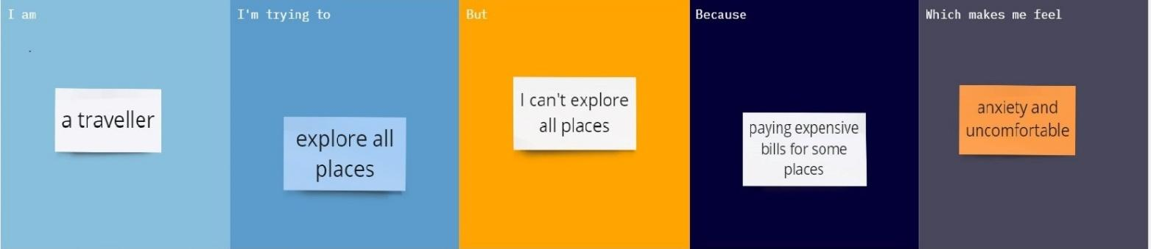

|  |  |  |  |  |  |
| --- | --- | --- | --- | --- | --- |
| **Problem**  **Statement(PS)** | **I am**  **(Customer)** | **I’m trying to** | **But** | **Because** | **Which makes me feel** |
| ***PS -1*** | Employee | Explore  all places | No time | Paying expensive bills for some places | Uncomfortable |
| ***PS -2*** | User | Explore  all places | No idea | No money | Tired |